**Practical No. 8**

**Q1. Create a simple HTML “Hello World” program**

**using AngularJS framework and apply ng-controller, ng-model and expressions**

**Code:**

<html>

<head>

<title>Working with AngularJS</title>

</head>

<body>

<script type="text/javascript" src="angular.min.js">

</script>

<div ng-app="">

<input type=text name="Myname" ng-model="name">

<br>

<h1>Hello...{{name}}</h1>

</div>

</body>

</html>

**Output:**

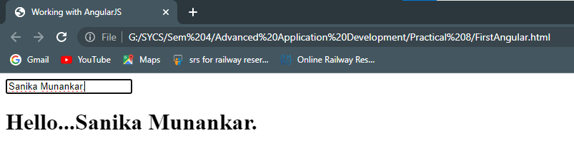

**Q2. Working with AngularJS Modules**

**Code:**

<html>

<body>

<div ng-app="" ng-init=" First_name='Sanika'; Last_name='Munankar' ">

<input type=text ng-model="First_name"><br><br>

<input type=text ng-model="Last_name"><br>

<h1>Hello...{{First_name}}</h1>

<h1>Welcome...{{Last_name}}</h1>

</div>

<script type="text/javascript" src="angular.min.js">

</script>

</body>

</html>

**Output:**

